DEPT. OF ELECTRICAL & ELECTRONICS ENGINEERING SRM INSTITUTE OF SCIENCE AND TECHNOLOGY, Kattankulathur – 603203.

|  |
| --- |
| Title of Experiment : Wave shaping circuits ( Half wave & Full  Rectifiers) |
| Name of the candidate : DHRUVIL PATEL    Register Number : RA2011003010559    Date of Experiment : 7/11/2020    Date of submission : 13/11/2020 |

|  |  |  |  |
| --- | --- | --- | --- |
| Sl.  No. | Marks Split up | Maximum marks  (50) | Marks obtained |
| 1 | Pre Lab questions | 5 |  |
| 2 | Preparation of observation | 15 |  |
| 3 | Execution of experiment | 15 |  |
| 4 | Calculation / Evaluation of Result | 10 |  |
| 5 | Post Lab questions | 5 |  |
|  | Total | 50 |  |

Staff Signature PRE LAB QUESTIONS (Rectifiers)

1. What is the necessity of rectifier?

Using a rectifier in the power supply helps in converting AC to DC power supply. Bridge rectifiers are widely used for large appliances, where they are capable of converting high AC voltage to low DC voltage

1. What is PIV of a diode in Full Wave Rectifier (FWR) and Half Wave Rectifier (HWR)?

Peak Inverse Voltage (PIV) is the maximum voltage that the diode can withstand during reverse bias condition. If a voltage is applied more than the PIV, the diode will be destroyed. Peak Inverse Voltage of single-phase center-tap full-wave rectifier is the maximum possible voltage across a diode when it is reversed-biased.

1. What is ripple factor? Why it is required?

Ripple factor is a measure of effectiveness of a rectifier circuit. It is defined as the ratio of RMS value of the AC component (ripple component) Irrms in the output waveform to the DC component VDC in the output waveform. When the fluctuation occurs within the output of the rectifier then it is known as ripple. So, this factor is essential to measure the rate of fluctuation within the resolved output. ... This capacitor helps to decrease the ripple within the rectifier output.

1. Why are filters connected at the output of rectifiers?

The filter is a device that allows passing the dc component of the load and blocks the ac component of the rectifier output. Thus, the output of the filter circuit will be a steady dc voltage. ... Capacitor is used so as to block the dc and allows ac to pass

1. What are the types of filters used in rectifier? And which is better and why?

Types of filters

Rectifiers are those circuit which provide DC as output but even if you use Bridge rectifier the output will have some AC component along with DC component. So, In order to reduce the AC component we will be using different types of filter at the output side of the rectifier. So, these filters are consisting of Inductors and capacitor.

Depending upon on the placement of inductor and capacitors we can have L - Section filter which consists of one inductor in series and capacitor in parallel and pi section filter which consists of 2 capacitors in Parallel along with inductor in between connected in series. The preferred one in pi section filter.

|  |  |
| --- | --- |
| Date : | SINGLE PHASE HALF WAVE RECTIFIER |

Aim

To construct a half wave rectifier using diode and to draw its performance characteristics. Apparatus Required Components Required

|  |  |  |  |  |  |  |  |  |
| --- | --- | --- | --- | --- | --- | --- | --- | --- |
| S.  No. | Name | Range | Qty |  | S.  No. | Name | Range | Qty |
| 1 | Transformer | 230/(6-0-6)V | 1 | 1 | Diode | IN4007 | 1 |
| 2 | R.P.S | (0-30)V | 2 |
| 2 | Resistor | 1K  | 1 |
| 3 | Bread  Board | - | 1 |
| 4 | Capacitor | 100µf | 1 |
| 5 | CRO | - | 1 |

Formulae

With out Filter

1. Vrms = Vm / 2
2. Vdc = Vm / 
3. Ripple Factor =  ((Vrms / Vdc)2 – 1)
4. Efficiency = (Vdc / Vrms)2 x 100

With Filter

1. Vrms =  (Vrms2 + Vdc2)
2. Vrms = Vrpp / (3 x 2)
3. Vdc = Vm – V rpp / 2
4. Ripple Factor = Vrms / Vdc

Procedure

Without Filter

* 1. Give the connections as per the circuit diagram.
  2. Give 230v, 50HZ I/P to the step down TFR where secondary connected to the Rectifier

I/P.

* 1. Take the rectifier output across the Load.
  2. Plot its performance graph.

With Filter

* 1. Give the connections as per the circuit diagram.
  2. Give 230v, 50HZ I/P to the step down TFR where secondary connected to the Rectifier

I/P.

* 1. Connect the Capacitor across the Load.
  2. Take the rectifier output across the Load.
  3. Plot its performance graph.

Circuit Diagram

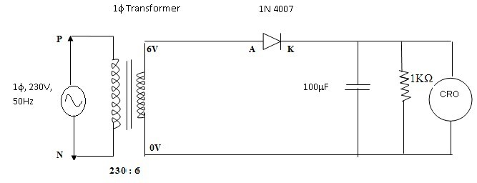

Model Graph



V

in

(

Vol



t

)

ms

(



V

o

Vol

(



t (ms)



t (ms)



V

o

(

Vol



Without



With

Tabular Column

|  |  |  |  |  |
| --- | --- | --- | --- | --- |
| Without Filter |  |  |  |  |
| Vm (V) | Vrms (V) | Vdc (V) | Ripple factor | Efficiency |
| 4.33 | 2.165 | 1.378 | 1.211 | 40.511% |

With Filter

|  |  |  |  |
| --- | --- | --- | --- |
| Vrpp (V) | Vrms (V) | Vdc (V) | Ripple factor |
| 0.85 | 0.245 | 3.895 | 0.062 |

Model Calculations:

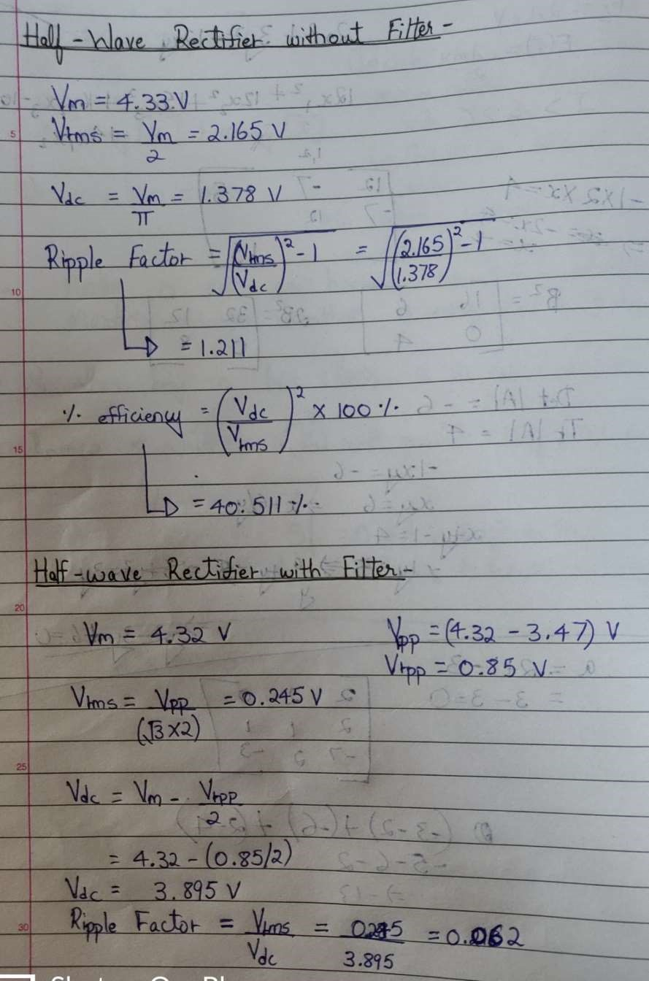

Simultion Diagram:

a) Without filter

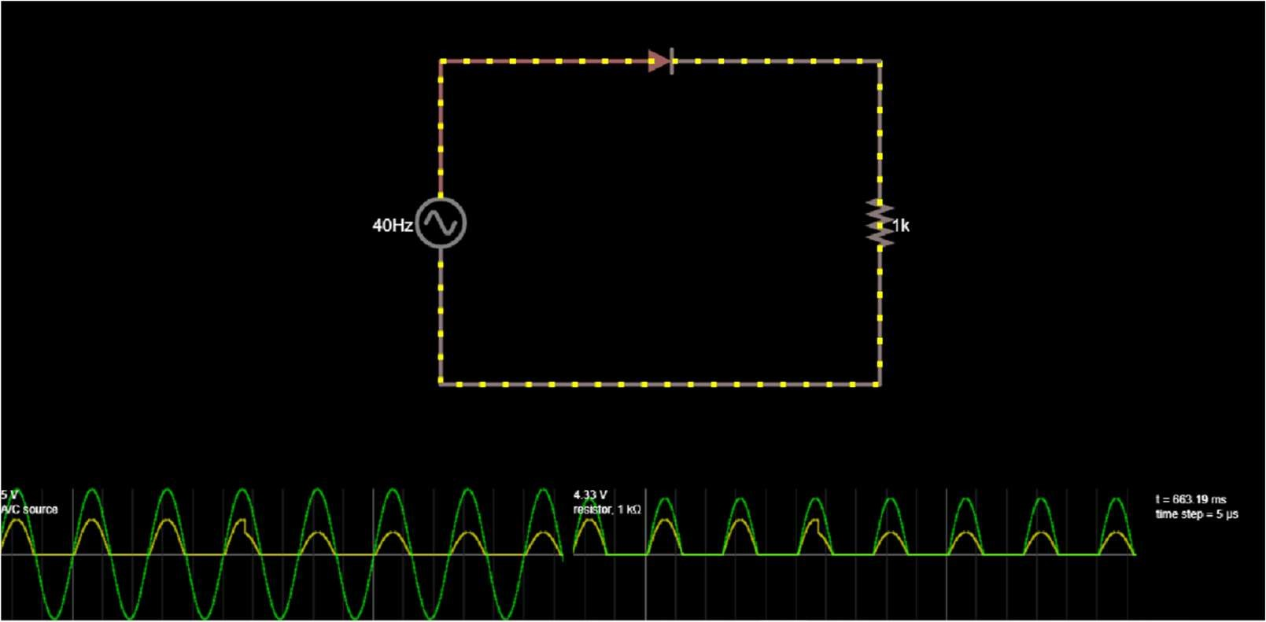

b)With filter

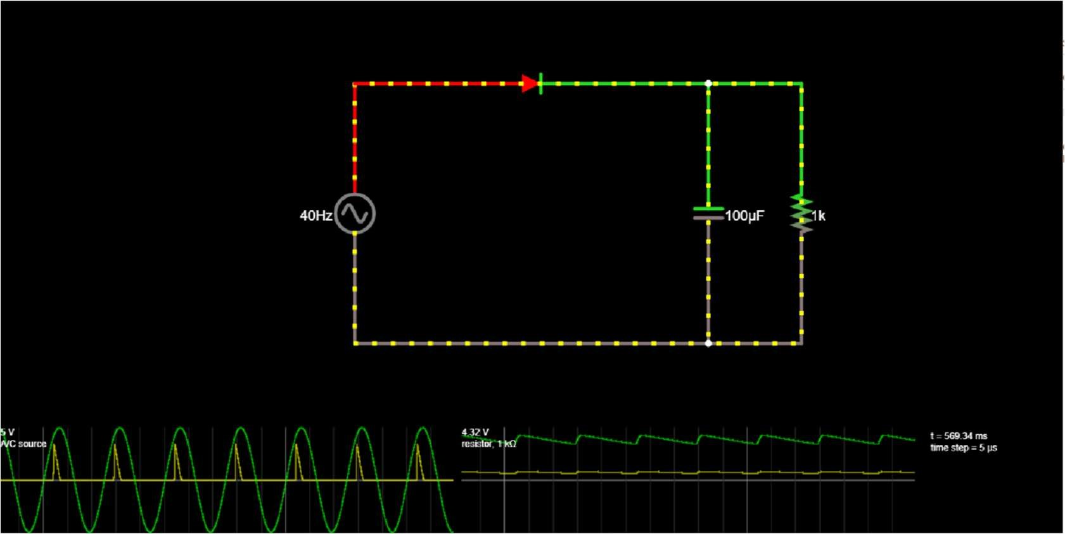

Result : The performance characteristics of half wave rectifier with/ without filter were studied.

|  |  |
| --- | --- |
| Date : | SINGLE PHASE FULL WAVE RECTIFIER |

Aim

To construct a single phase full-wave rectifier using diode and to draw its performance characteristics.

Apparatus Required Components Required

|  |  |  |  |  |  |  |  |  |
| --- | --- | --- | --- | --- | --- | --- | --- | --- |
| S.  No. | Name | Range | Qty |  | S.  No. | Name | Range | Qty |
| 1 | Transformer | 230/(6-0-6)V | 1 | 1 | Diode | IN4007 | 2 |
| 2 | R.P.S | (0-30)V | 2 |
| 2 | Resistor | 1K  | 1 |
| 3 | Bread  Board | - | 1 |
| 4 | Capacitor | 100µf | 1 |
| 5 | CRO | 1Hz-  20MHz | 1 |
|  | 6 | Connecting wires | - | Req |

Formulae

Without Filter

1. Vrms = Vm / 2
2. Vdc = 2Vm / 
3. Ripple Factor =  ((Vrms / Vdc)2 – 1)
4. Efficiency = (Vdc / Vrms)2 x 100

With Filter

1. Vrms = Vrpp /(2* 3)
2. Vdc = Vm – V rpp

(iv) Ripple Factor = Vrms’/ Vdc

Procedure

Without Filter

1. Give the connections as per the circuit diagram.
2. Give 230v, 50HZ I/P to the step down TFR where secondary connected to the

Rectifier I/P.

1. Take the rectifier output across the Load.
2. Plot its performance graph.

With Filter

1. Give the connections as per the circuit diagram.
2. Give 230v, 50HZ I/P to the step down TFR where secondary connected to the Rectifier

I/P.

1. Connect the Capacitor across the Load.
2. Take the rectifier output across the Load.
3. Plot its performance graph.

Circuit Diagram

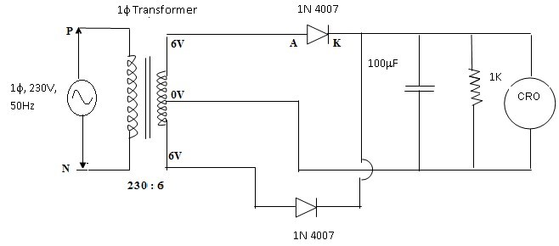

Tabular Column

Without Filter

|  |  |  |  |  |
| --- | --- | --- | --- | --- |
| Vm | Vrms | Vdc | Ripple factor | Efficiency |
| 3.67 | 2.59 | 2.33 | 0.485 | 80.9 |

With Filter

|  |  |  |  |
| --- | --- | --- | --- |
| Vrms | Vrpp | Vdc | Ripple factor |
| 0.101 | 0.35 | 3.28 | 0.0307 |

Model Graph



V

in

V

(



t



V

o

V

(



t



t



V

o

(

V



Witho



Wit

Model Calculations:

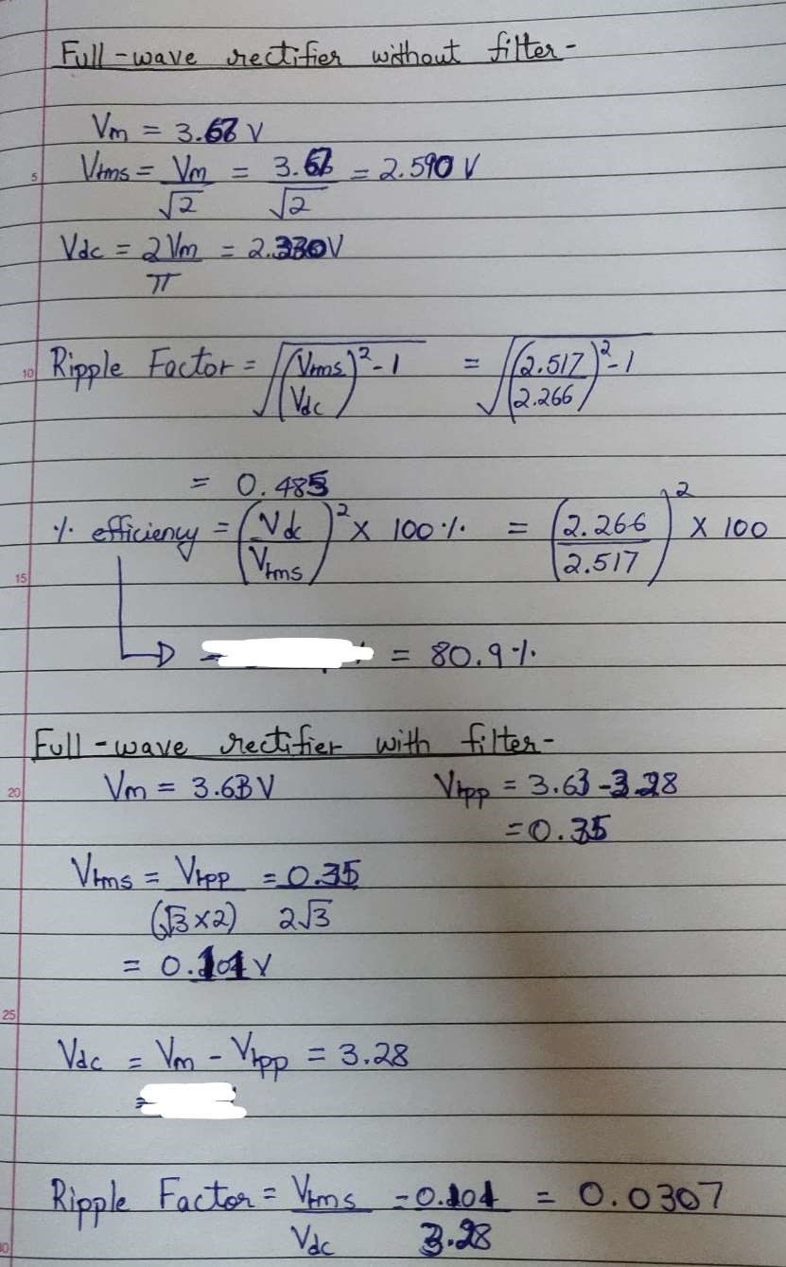

Simultion Diagram:

a) Without filter

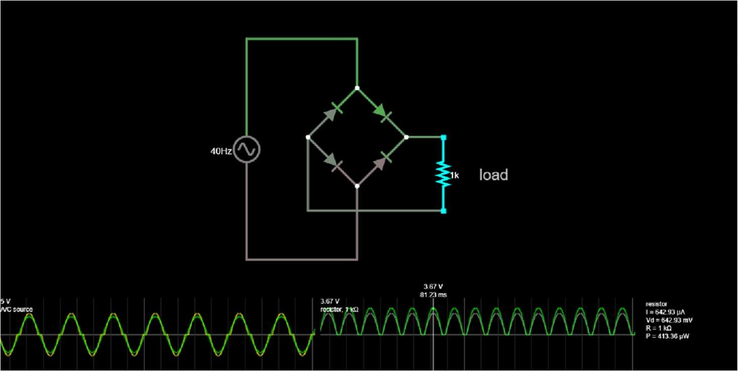

b)With filter

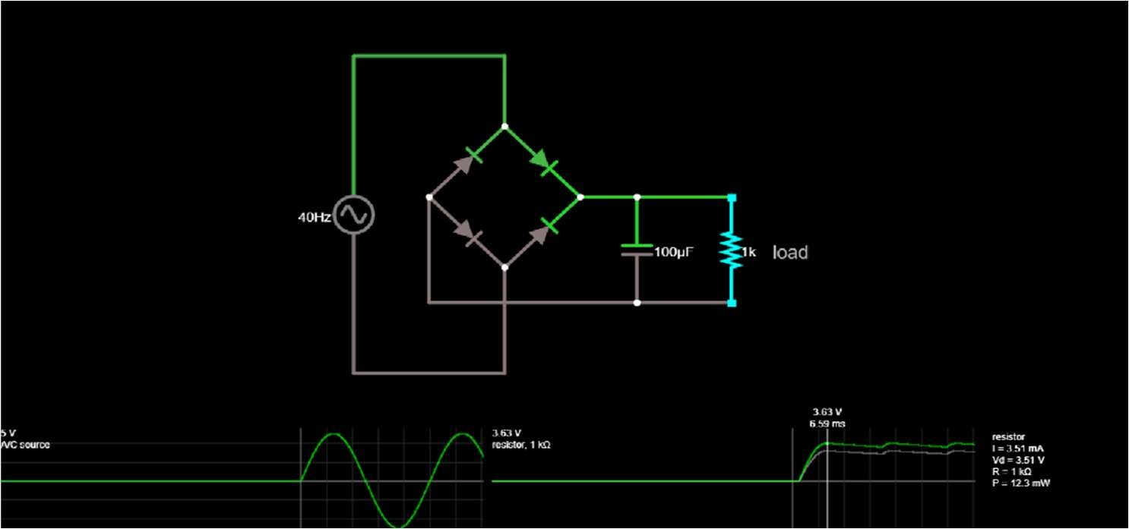

Result : The performance characteristics of full wave rectifier with/ without filter were studied.

POST LAB QUESTIONS

1. What is Transformer Utilization Factor (TUF)?

Transformer Utilization Factor (TUF) is defined as the ratio of DC power output of a rectifier to the effective Transformer VA rating used in the same rectifier. Effective VA Rating of transformer is the average of primary and secondary VA rating of transformer.

1. Mention the value of ripple factor for HWR, FWR & rectifier with centre tapped transformer.

Ripple Factor of Half Wave Rectifier

R.F = √ (Im/2 / Im/ π)2 -1 = 1.21

Ripple Factor of Full Wave Rectifier

R.F = √ (Im/√ 2/ 2Im / π)2 -1 = 0.48

Ripple Factor of single-phase centre-tap full-wave rectifier γ = Iac /Idc = √ {(I2 + Idc2)/Idc} = √[{Irms/Idc}2 – 1] = √ (Kf2 – 1)

1. What is the difference between uncontrolled rectifier and controlled rectifier? Which is advantageous and why?

An uncontrolled rectifier is a simple diode which conducts for half cycle or 180 degree of sinewave and remains cut-off for remaining 180 degrees. In a controlled rectifier, the conduction can start at any angle in positive half cycle - namely 0 to 180 degree. Once the conduction starts (rectifier or device is fired) it cannot be turned off. During negative half cycle it gets turned off. A controlled rectifier is advantageous over an uncontrolled one because it can compensate the DC line voltage variations caused by voltage variations on the medium voltage power network and keep voltage constant even in case of load variations and also control the fault current on faults far from the electrical substation and consequently help increase line protection settings.

1. State the average and peak value of output voltage and current for full wave rectifier and half wave rectifier.

Full wave rectifier-

Vavg= 2Vm/π ; Iavg= 2I0/π

Vmax= V0 ; Imax=I0

Half wave rectifier- Vavg= Vm/π ; Iavg= 0.318 I0

Vmax= V0 ; Imax=I0

1. What is PIV of a diode in half wave and full wave rectifier?

Peak Inverse Voltage (PIV) is the maximum voltage that the diode can withstand during reverse bias condition. If a voltage is applied more than the PIV, the diode will be destroyed. Peak Inverse Voltage of single-phase center-tap fullwave rectifier is the maximum possible voltage across a diode when it is reversedbiased.

• DHRUVIL PATEL__RA2011003010559